1 Check the R environment

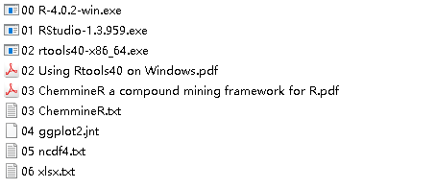

2 Download “TempMatching10xWMStd.7z”, unzip the file. Keep the structure of this work folder.

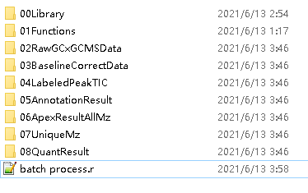

3 download the “Data for testing”, unzip the data file to folder “02RawGCxGCMSData”

4 open “batch process.r” change the “FolderRoute” and run the scripts

5 before “check the data subtraction result”, Re-start the R for close the channel to the netCDF data file(close the channel in R may not work).